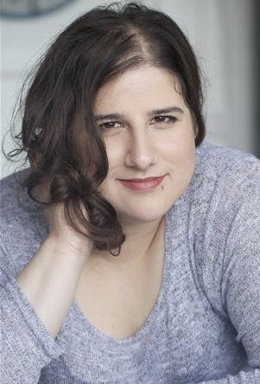
SUSANA RODRIGUES
53 Dovet Court
Mursell Estate
London
SW8 1HS
Phone: 07484 790 339
Email: info@susanarodrigues.co.uk

For more videos or information, please visit: www.susanarodrigues.co.uk

Location: London, United Kingdom Eye Colour: Brown
Height: 5’7” (170cm) Hair Colour: Brown
Weight: 14st. (94kg) Hair Length: Shoulder Length
Playing Age: 25 – 35 years Voice Character: Engaging
Appearance: Caucasian, Hispanic, Voice Quality: Warm
Latina, Italian, Mediterranean Photo: John Bucknall

Feature Film
2013, Tourist, Hichestan, Blackmount Pictures & Artimana Media Ltd, Hernan Diaz Laserna & Tiger Musigapong

Short Film
2018, Rodie, You’ve Got Instagram, Invisible Sword Productions, David John Jeffery & Susana Rodrigues
2017, Maggie, Captured, Invisible Sword Productions, David John Jeffery & Susana Rodrigues
2016, Interviewer, Save The Mosquitoes, Invisible Sword Productions, David John Jeffery & Susana Rodrigues
2014, Diane, Tiddly Toos, Nathan Miller
2014, Nympha, Optical Illusion, Black Light Enterprises & Pine Box Films, David John Jeffery & Susana Rodrigues
2013, Rachel, Outline, Black Light Enterprises, David John Jeffery
2013, Secretary, No Easy Way Out, Art Spaces Ltd, Sylwia Kaczmarek
2012, Christine, My Life To Live, Cheng Huan Li

Accents & Dialects: (* = native)
American-Southern States, American-Standard, Brazilian, English-Standard, Italian, London, Portuguese*, RP

Languages: (* = Native/Fluent)
Brazilian Portuguese, English, Portuguese*

Music & Dance: (* = highly skilled)
Contemporary Dance, Contemporary Singing, Keyboards, Tap Dancing

Performance:
Actor-Singer, Children's Theatre, Comedy, Green Screen/Chroma Key, Live Roleplay, Musical Theatre, Street Theatre, Voice Over

Sports: (* = highly skilled)
Badminton*, Bowling, Cycling, Fencing, Football, Karting, Pool, Running, Swimming, Table Tennis

Other Skills:
Ambidextrous, Camera Operator, Comedy Songwriting, Computer Literate, Director, Filmmaker, Improvisation, Lyricist, Narration, Photography, Translating, Vision Mixer, Writer, Artist, Painter, Scriptwriter, Editor

Training:
Drama Centre London, MA Screen, 2011

